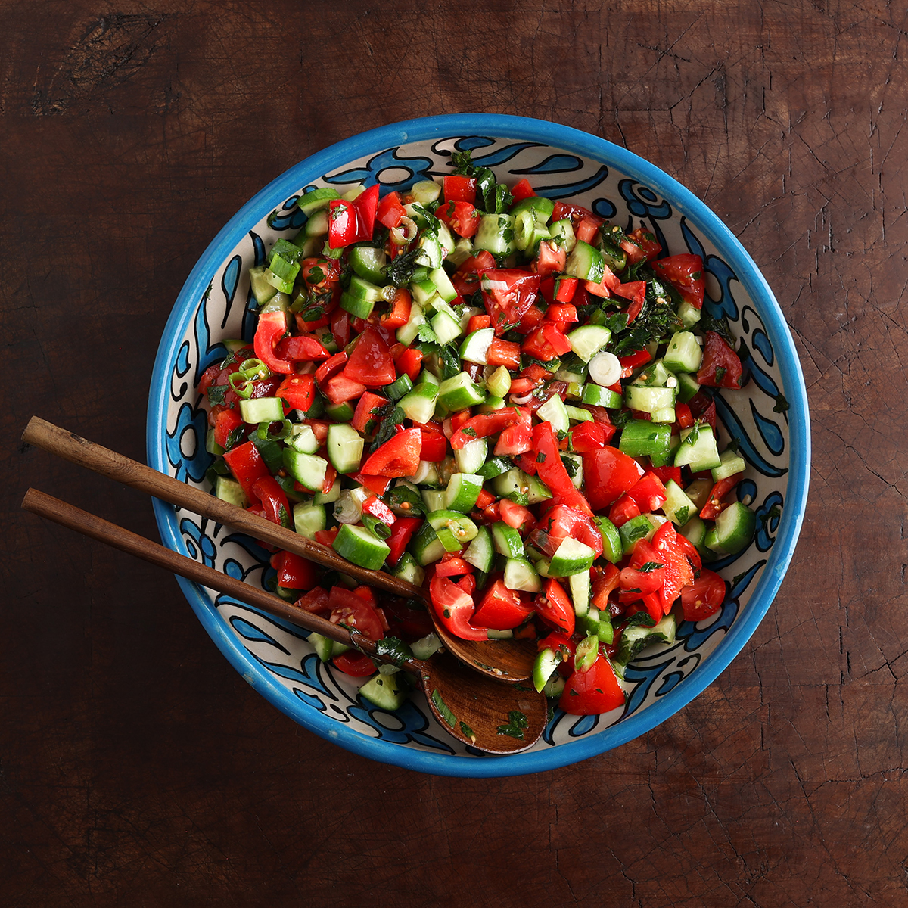

Israeli Cucumber Tomato Salad
By @bitemeindustries
This refreshing Israeli Cucumber Tomato Salad is a year-round favorite made with crisp cucumbers, juicy tomatoes, and bright herbs—perfect alongside shawarma, kebabs, or rice dishes.
INGREDIENTS
The Dressing
3 tablespoons extra virgin olive oil (45 ml), good quality
2 tablespoons lemon juice (30 ml)
Salt and pepper to taste
The Salad
4 medium tomatoes, chopped (400 g)
4 Persian cucumbers, chopped (500 g)
1 red bell pepper, chopped (150 g)
3 green onions, chopped (45 g)
¼ cup flat-leaf parsley, finely chopped (10 g)
¼ cup fresh mint, finely chopped (10 g)
INSTRUCTIONS
1. Dressing. In a large bowl, add the extra virgin olive oil (EVOO), lemon juice, of salt and fresh cracked black pepper. Whisk together. This is not the time to skip on quality olive oil.
2. Make the salad. Chopped tomatoes, cucumber, red bell pepper, and green onions into ¼” to ½” (6-12mm in size) pieces, keeping them uniform. Into the large bowl with the dressing, add all the salad ingredients, toss to coat the vegetables and herbs. Taste and adjust the seasoning.
RECIPE TIPS
Chop evenly: Aim to dice all ingredients into small, uniform pieces—about ¼ to ½ inch (6–12 mm). Keeping the tomatoes, cucumbers, and peppers roughly the same size ensures even flavor and easy bites.
Seed juicy tomatoes: If your tomatoes are especially juicy or packed with seeds, consider removing the seed cavities to avoid excess liquid in the salad.
Peel the cucumber (optional): If using larger cucumbers like English or pickling varieties, peeling and seeding them before chopping can improve texture and reduce bitterness.
Add a Greek twist: For a Mediterranean variation, toss in a handful of crumbled feta for a salty, creamy touch.
RECIPE INFO:
Servings: 6
Serving Size: 1 cup (depending on yield)
Yields: About 6 cups (1.4 liters)
Prep Time: 15 minutes
Cook Time: 0 minutes
Custom Time: None
Total Time: 15 minutes
Category: Side Dish, Salad
Featured Produce: Tomatoes, Cucumbers, Fresh Herbs
Courses: Side Dish, Salad, Mezze
Cuisines: Middle Eastern, Mediterranean
Diet: Vegetarian, Vegan, Gluten-Free, Dairy-Free, Egg-Free, Nut-Free
Season: Summer, Year-Round
Months: May–September for peak freshness, but adaptable year-round

ISRAELI CUCUMBER TOMATO SALAD
Most commonly referred to as Jerusalem Salad, this bright and refreshing Israeli Cucumber Tomato Salad is a quick, healthy side dish featuring crisp cucumbers, juicy tomatoes, and zesty lemon dressing. Also known as a Middle Eastern Chopped Salad, it brings fresh flavor to any meal and is naturally vegan, gluten-free, and packed with nutrients.
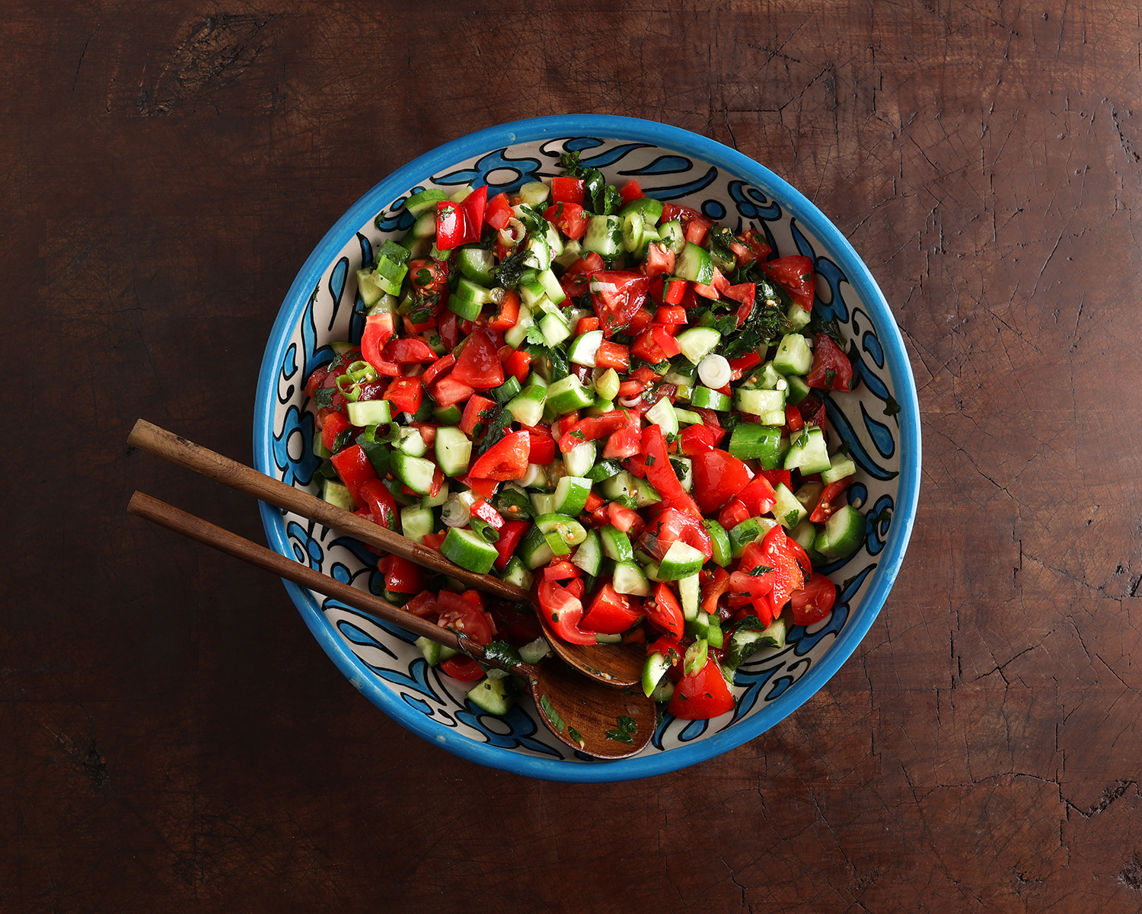

WHY YOU WILL LOVE THIS MIDDLE EASTERN CHOPPED SALAD
This Israeli Cucumber Tomato Salad is incredibly versatile, easy to make, and ready in just 15 minutes. Its crisp textures and citrusy bite make it a favorite for pairing with shawarma, kebabs, rice dishes, or as a vibrant component in a mezze spread.
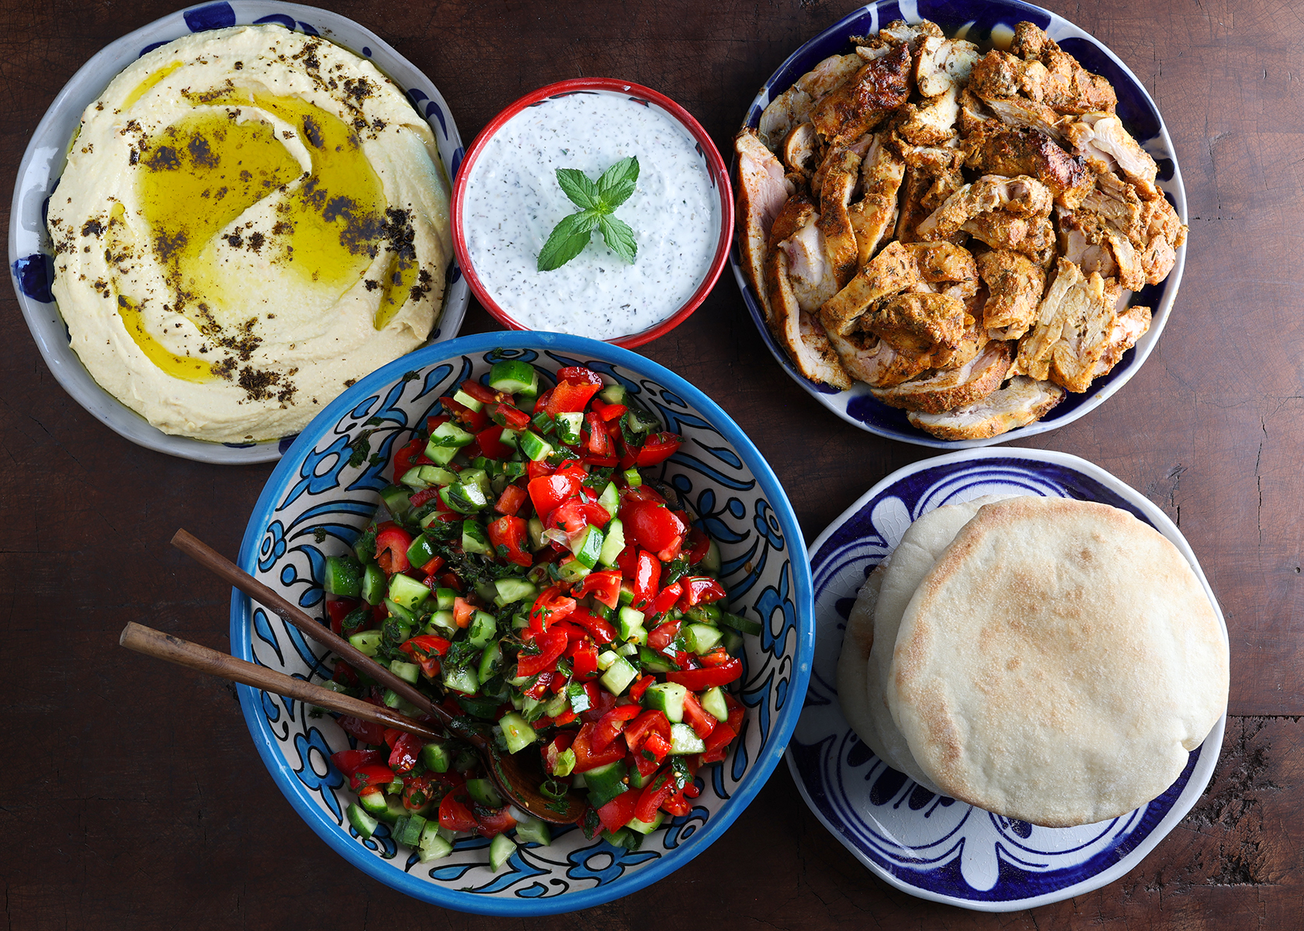

INGREDIENTS FOR THIS MIDDLE EASTERN CHOPPED SALAD
- Tomatoes: Juicy and slightly acidic, tomatoes provide a fresh, sweet balance and a pop of color to this Middle Eastern chopped salad. They are also a great source of vitamin C and antioxidants.
- Persian Cucumbers: These small, thin-skinned cucumbers are extra crisp and seedless, giving the salad a cool, clean crunch without excess moisture.
- Red Bell Pepper: Adds a touch of natural sweetness and vibrant color while offering a boost of vitamin C.
- Green Onions: These add a mild, oniony flavor without overpowering the salad. They enhance freshness and aromatic depth.
- Flat-Leaf Parsley: Brings an earthy, herbaceous note that complements the citrus and vegetables.
- Fresh Mint: Delivers a refreshing, cooling contrast that lifts the whole dish and ties into the Mediterranean profile.
- EVOO (Extra Virgin Olive Oil): Acts as the silky base of the dressing, helping the flavors coat each bite. Use a good-quality extra virgin olive oil for the best results.
- Lemon Juice: Adds brightness and zing that balances the olive oil and enhances all the other flavors.
- Salt and Pepper: Essential for seasoning and bringing all the flavors to life. Use freshly cracked pepper for extra aroma.
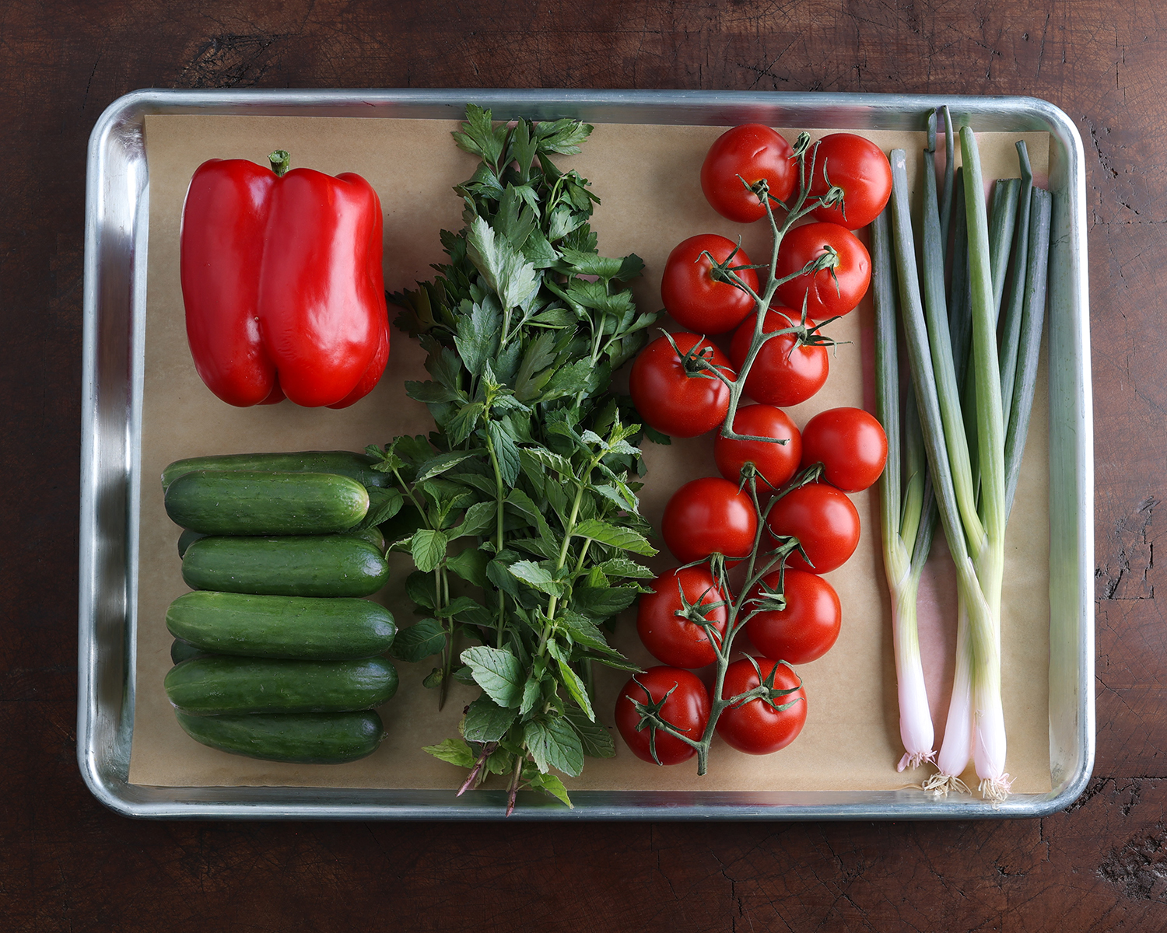

HOW TO MAKE ISRAELI CUCUMBER TOMATO SALAD (a.k.a. Jerusalem Salad)
- Make the dressing: In a large bowl, add the extra virgin olive oil (45 ml), lemon juice (30 ml), salt, and freshly cracked black pepper. Whisk together. This is not the time to skip on quality olive oil.
- Chop the vegetables: Chop the tomatoes (400 g), Persian cucumbers (500 g), red bell pepper (150 g), and green onions (45 g) into 1/4 to 1/2 inch (6-12 mm) pieces, keeping everything uniform.
- Toss the salad: Into the bowl with the dressing, add the chopped vegetables, flat-leaf parsley (10 g), and fresh mint (10 g). Toss to coat well.
- Taste and adjust: Taste and adjust seasoning with more salt or lemon juice if needed. Serve immediately.
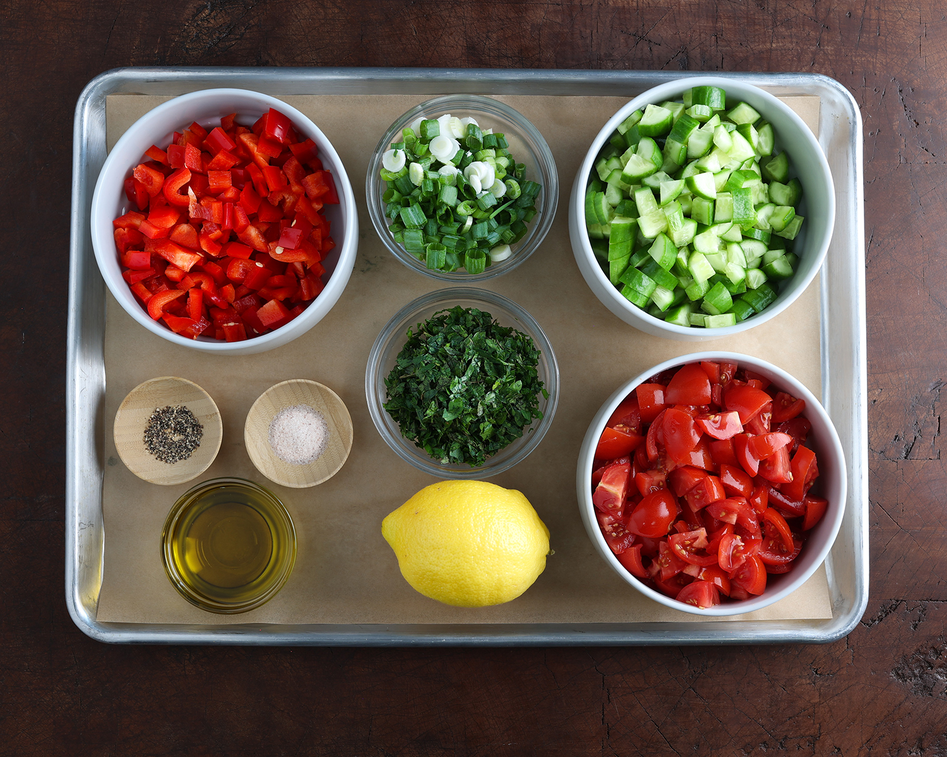

THE BEST TOMATOES FOR JERUSALEM SALAD
For Jerusalem Salad, the best tomatoes are ones that are firm, flavorful, and not overly watery. Here are a few great options:
- Roma (Plum) Tomatoes: Their low moisture and dense flesh make them ideal for salads where you want to avoid sogginess.
- Campari Tomatoes: These are juicy but balanced, with a rich, sweet flavor and fewer seeds.
- Vine-Ripened Tomatoes: As long as they’re firm and fresh, they bring excellent flavor—especially when in season.
- Cherry or Grape Tomatoes: If chopped finely, these work well too. They’re sweet, less watery, and add vibrant color.
Avoid overly ripe or soft tomatoes, which can make the salad too wet and mushy. When possible, choose locally grown, in-season tomatoes for the best flavor.

THE BEST CUCUMBER SOR JERUSALEM SALAD
The best cucumbers for Jerusalem Salad are crisp, thin-skinned, and low in seeds, offering a refreshing crunch without excess moisture. Top choices include:
- Persian Cucumbers: Obviously these are the #1 choice for texture, flavor, and culturally authentic. Small, seedless, and extra crisp. Their tender skin means no peeling required, making them the most traditional and convenient option.
- English Cucumbers (Hothouse Cucumbers): Long and thin with very few seeds and mild flavor. Peel if the skin is waxy or tough.
- Kirby Cucumbers: Short and bumpy, these are often used for pickling but are great in salads too. They're crunchy with small seeds.
Avoid standard American slicing cucumbers, which are often waxed and have large, watery seed cavities that can dilute the salad’s texture and flavor.

MAKING AHEAD
This Jerusalem salad is best when made fresh. I don’t recommend making it ahead, considering it only takes 15 minutes. However, it can be made 1 day ahead of time, simply keep the dressing separate and dress just before serving.
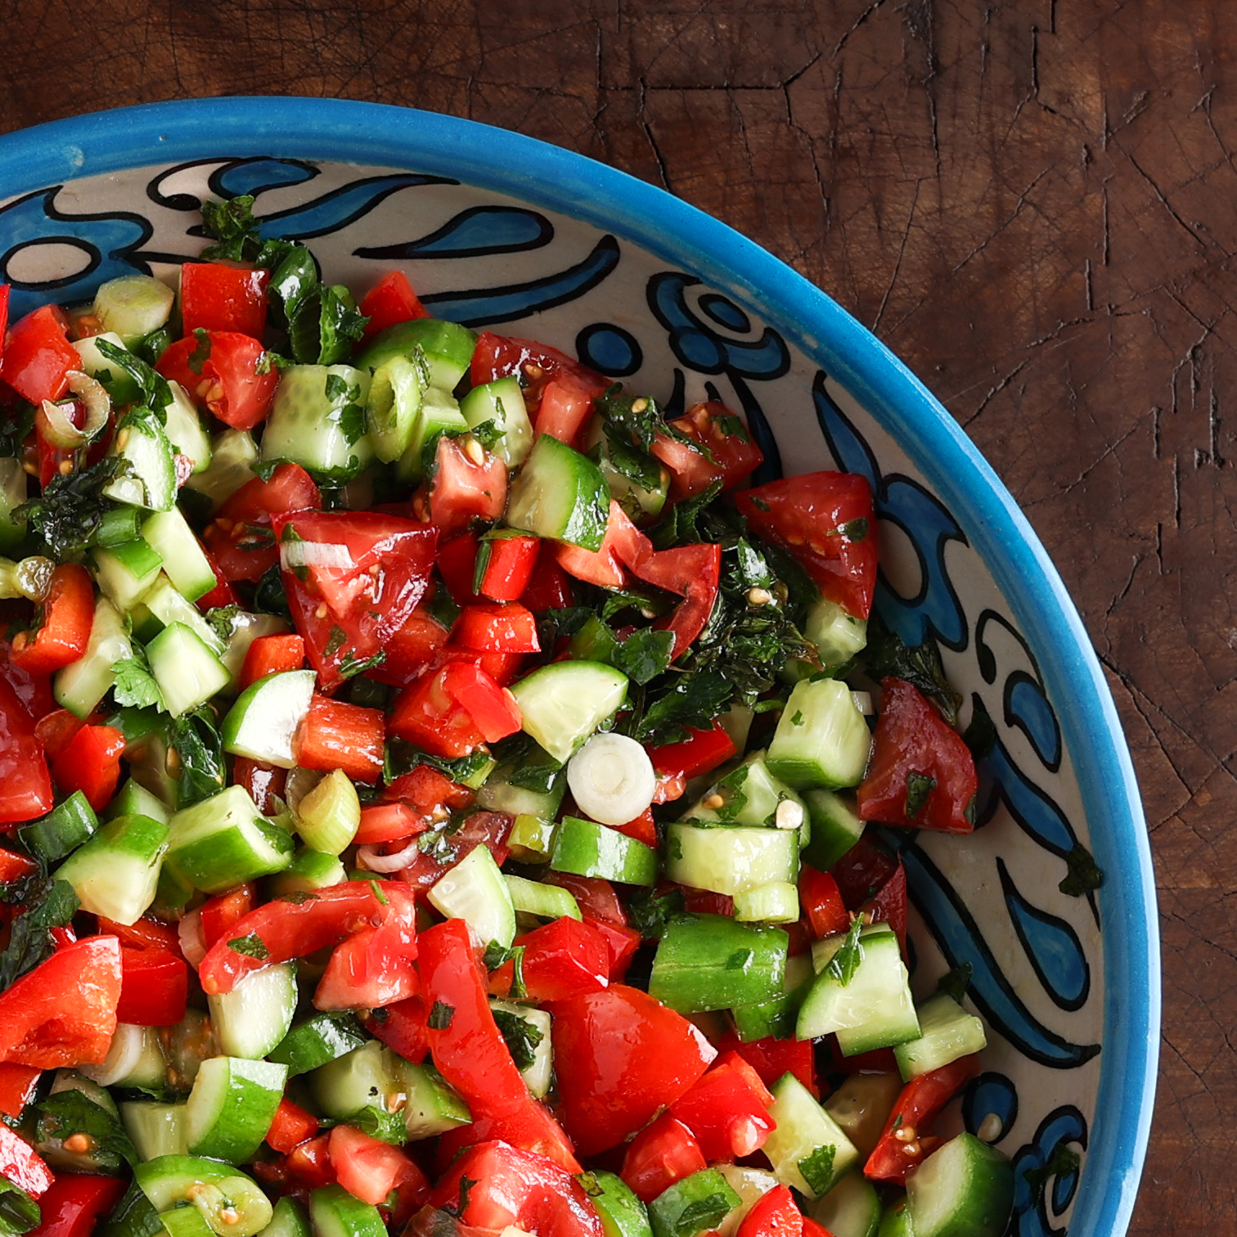

JERUSALEM SALAD: A BRIEF HISTORY
Jerusalem salad is a simple, refreshing mix of finely chopped tomatoes, cucumbers, onions, and fresh herbs, typically dressed with lemon juice and olive oil. Its origins lie in the Levant, where it’s a staple side dish across Israeli and Palestinian kitchens. While the name “Jerusalem salad” is common in Israel, it’s known more broadly as Arabic salad (Salata Arabieh) or Israeli salad, depending on the region and context.
This salad reflects the shared culinary traditions of the Middle East, where fresh vegetables, olive oil, and citrus are foundational ingredients. It's often served alongside falafel, shawarma, hummus, or grilled meats, and is loved for its bright, crisp, and cooling contrast to warm, spiced dishes.
This is a fun summer salad when cucumbers and tomatoes are fresh off the vine, however, this can be made year-round. This is a perfect side salad next meat and rice dishes such as kababs and shawarma’s that are served with rice.

EQUIPMENT NEEDED
- Large serving bowl: To whisk the dressing and combine all ingredients.
- Sharp chef's knife: For clean, even chopping of vegetables and herbs.
- Cutting board: A sturdy surface to prep your fresh produce.
- Measuring spoons and cups: To measure the olive oil and lemon juice accurately.
- Whisk or fork: For emulsifying the dressing quickly.
- Serving spoon or tongs: For tossing and serving the salad with ease.

(H2) DIETARY CONSIDERATIONS
- DF = Dairy-Free: This recipe contains no dairy ingredients.
- EF = Egg-Free: There are no eggs used in this salad.
- GF = Gluten-Free: Naturally free from gluten-containing ingredients.
- NF = Nut-Free: No nuts are included, making it safe for nut allergies.
- PB = Plant-Based: All ingredients are plant-derived.
- SF = Sugar-Free: No added or natural sugars in the recipe.
- VE = Vegetarian: Contains no meat, poultry, or fish.
- VG = Vegan: Fully vegan with no animal products.
- Paleo: Complies with paleo guidelines—free of grains, legumes, and processed foods.
- Keto: Not keto-friendly due to higher carb content from tomatoes and peppers.
- Whole30: Suitable if salt is compliant and no cheese is added.

#IsraeliSalad
#JerusalemSalad
#CucumberTomatoSalad
#MiddleEasternSalad
#HealthySideDish
#PlantBasedRecipes
#FreshHerbSalad
#MediterraneanEats
#EasySaladRecipe
#WholeFoodCooking
#SummerSaladIdeas

